EXERCISE 9

- List the minimum perks packages.
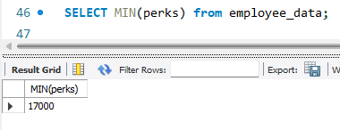
- List the maximum salary given to a “Programmer”.
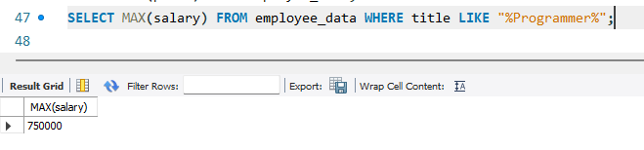
- Display the age of the oldest “Marketing Executive”.
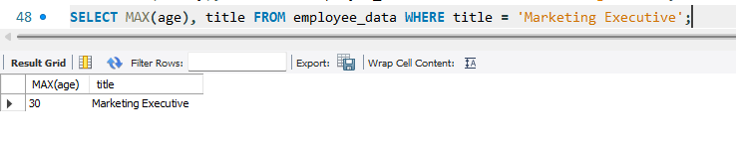
- Find the first and last names of the oldest employee.
